1.1. Basic Data Structures: Arrays, Stack, Queue, Linked list, Tree and Graph
1. Basic Data Structures Overview
- Linear Data Structures: Arrays, Stacks, Queues, Linked Lists.
- Non-Linear Data Structures: Trees, Graphs.
- Static vs. Dynamic Allocation:
  - Static: Fixed size at compile time (e.g., standard Arrays).
  - Dynamic: Memory allocated at runtime; resizable (e.g., Dynamic Arrays, Linked Lists).
2. Dynamic Lists vs. Static Arrays
- Definition: A dynamic list is a flexible data structure that grows or shrinks dynamically in memory during execution.
- Advantages of Dynamic Lists:
  - Dynamic Sizing: No need to specify fixed memory capacity beforehand.
  - Efficient Insertions/Deletions: Re-linking pointers takes $O(1)$ time at known positions without shifting contiguous elements.
  - Optimal Memory Utilization: Allocates memory on-demand from the heap, reducing waste.
- Disadvantages:
  - Pointer Overhead: Requires extra memory for storing node references (next, prev).
  - No Direct/Random Access: Sequential traversal required ($O(n)$ time complexity to access the $k$-th element).
  - Cache Inefficiency: Non-contiguous memory allocation leads to higher cache misses compared to arrays.
3. Key Algorithms to Practice
Insertion at the Beginning of a Doubly Linked List
- Steps:
  - Allocate memory for newNode and set newNode.data = value.
  - Set newNode.prev = NULL and newNode.next = head.
  - If head != NULL, set head.prev = newNode.
  - Update head = newNode.
Insertion at the End of a Doubly Linked List
- Steps:
  - Allocate memory for newNode and set newNode.data = value, newNode.next = NULL.
  - If head == NULL, set newNode.prev = NULL, head = newNode, and exit.
  - Traverse to the last node using a pointer temp until temp.next == NULL.
  - Set temp.next = newNode and newNode.prev = temp.
Circular Queue Operations
- Definition: A linear data structure operating on FIFO (First In, First Out) principle where the last position is connected back to the first position to form a circle, resolving memory wastage in linear array queues.
- Condition for Full: (rear + 1) % SIZE == front
- Condition for Empty: front == -1
4. Graph Representations & Applications
Adjacency Matrix vs. Adjacency List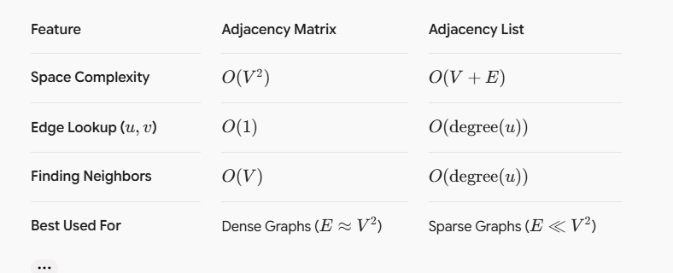Social Media Graph Representation & Analytics
- Graph Type Selection:
  - Undirected Graph: Mutual relationships (e.g., Facebook friends).
  - Directed Graph: Asymmetric relationships (e.g., Twitter/X followers).
- User Recommendation Approach (Common Neighbor / Collaborative Filtering):
  - 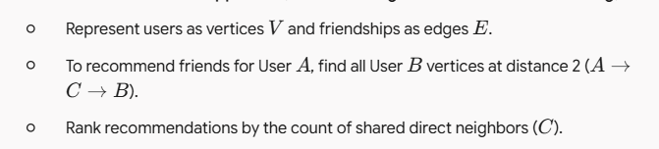
- Identifying Influential Users (Centrality Metrics):
  - Degree Centrality: Count incoming edges (highest follower count).
  - PageRank / Eigenvector Centrality: Measure node influence recursively based on incoming links from other highly influential nodes.

